01) What is Jenkins pipeline?

*- Jenkins pipeline is a collection of plugins which supports implementing and integrating continuous delivery pipelines into Jenkins. A continuous delivery pipeline is an automated expression of your process for getting software from version control right through to your users and customers.*

02) What scripting language is Jenkins pipeline syntax based on?

*- Groovy (java-language)*

03) What are the ways you can write pipeline in Jenkins?

|  |  |
| --- | --- |
| **Scripted Pipeline** | **Declarative Pipeline** |
| A scripted pipeline uses the Groovy (JVM-based) language to create a pipeline as code  -Problems with scripted pipeline:   * • The imbalance between developers’ experience in Groovy and Jenkins creates an impedance mismatch that is not easy to remove. * • Although scripted syntax is powerful and expedites the creation of complex pipelines, it concurrently makes the pipeline hard to read and hard to manage | The declarative pipeline follows a relatively newer syntax, which narrows the scope of the pipeline structure through a pre-defined “minimum necessary structure.” On the technical front, the declarative syntax follows a conditional statement logic that generates a series of stages, executed sequentially throughout the pipeline’s lifecycle. declarative pipelines don’t make use of Groovy code, the declarative syntax doesn’t access valuable APIs. |
|  |  |

04) Create jenkins pipeline for your repo and use script file (jenkinsfile) to write pipeline syntax?

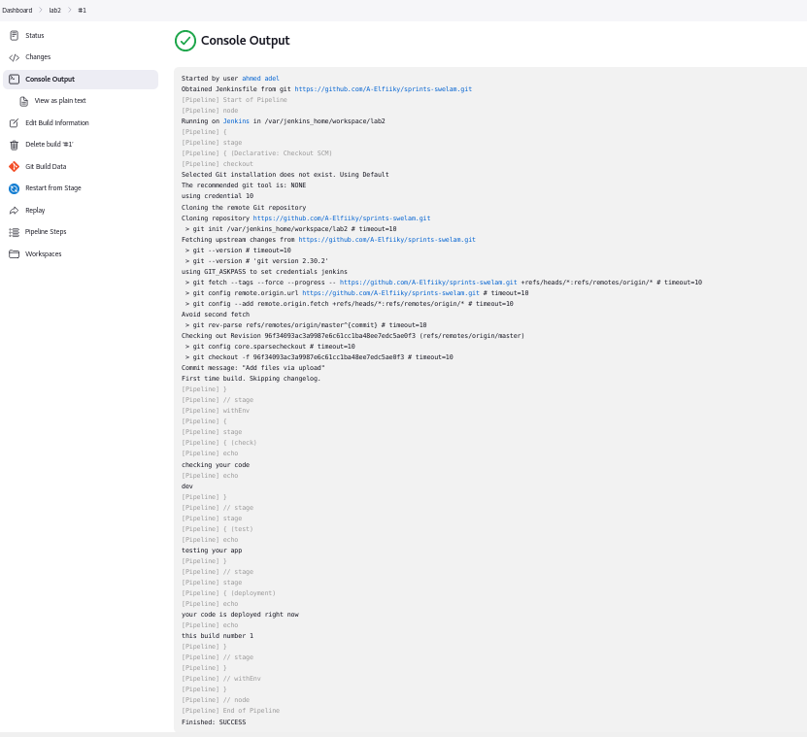

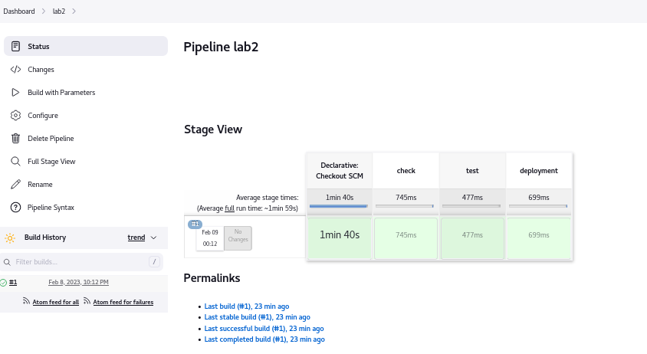

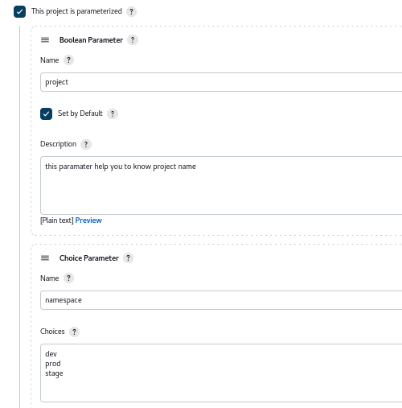

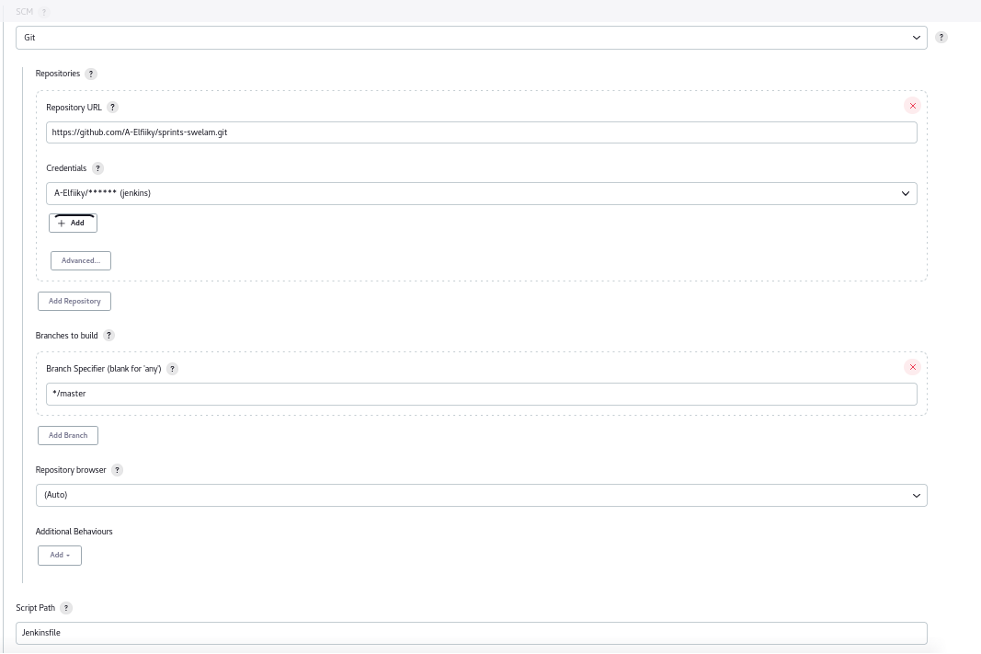

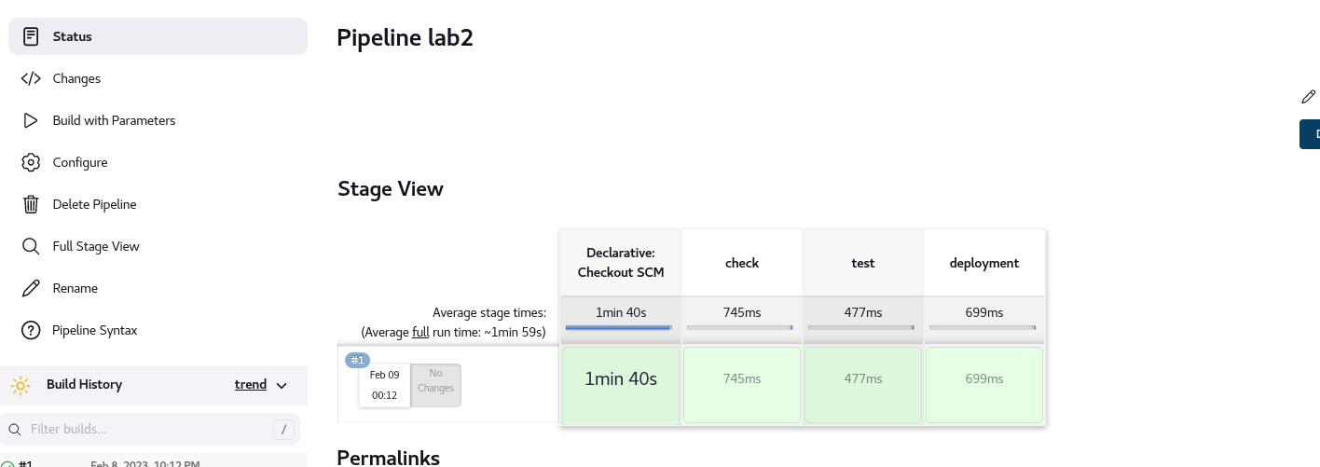

05) Create another multibranch pipeline and filter branches to contain only (master, dev, test)?

